- Python Expressions & F-Strings
1. Write a Python program to accept two numbers and display their sum, difference, multiplication, and division.
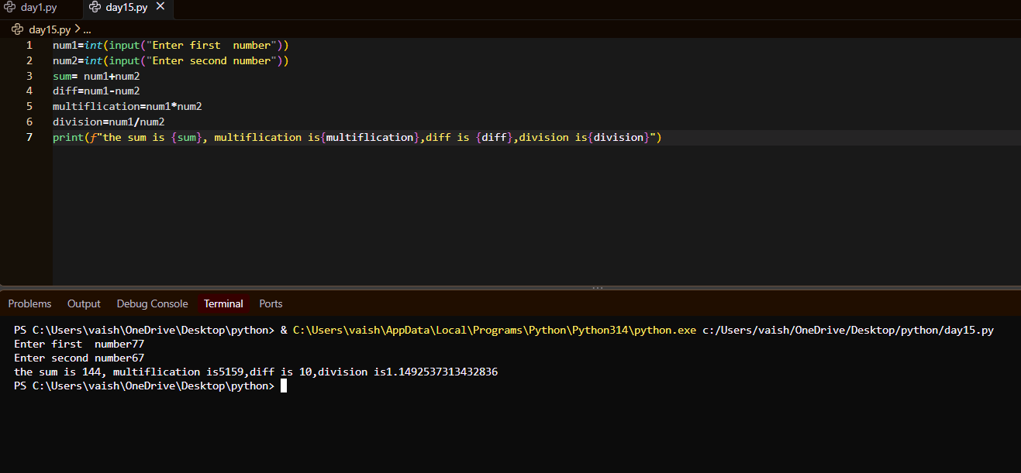
2. Write a program to calculate the area and perimeter of a rectangle using the length and breadth entered by the user.
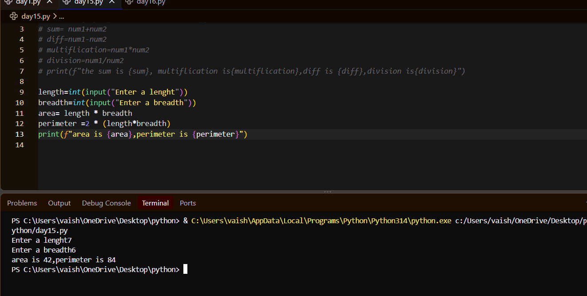
3. Write a Python program to accept a student's name, age, and marks and display the information using an f-string.
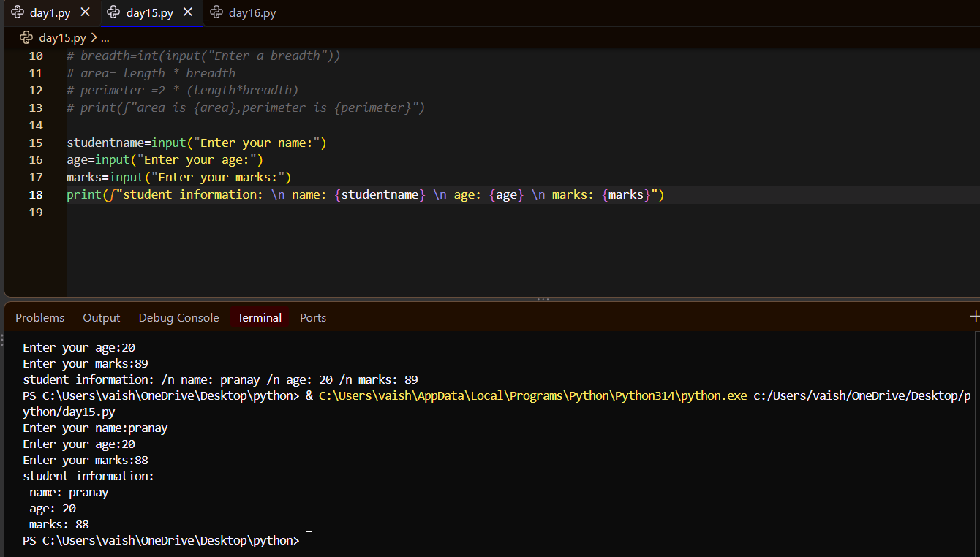
4. Write a program to accept the price and quantity of a product and calculate the total price. Display the result using an f-string in the following format:
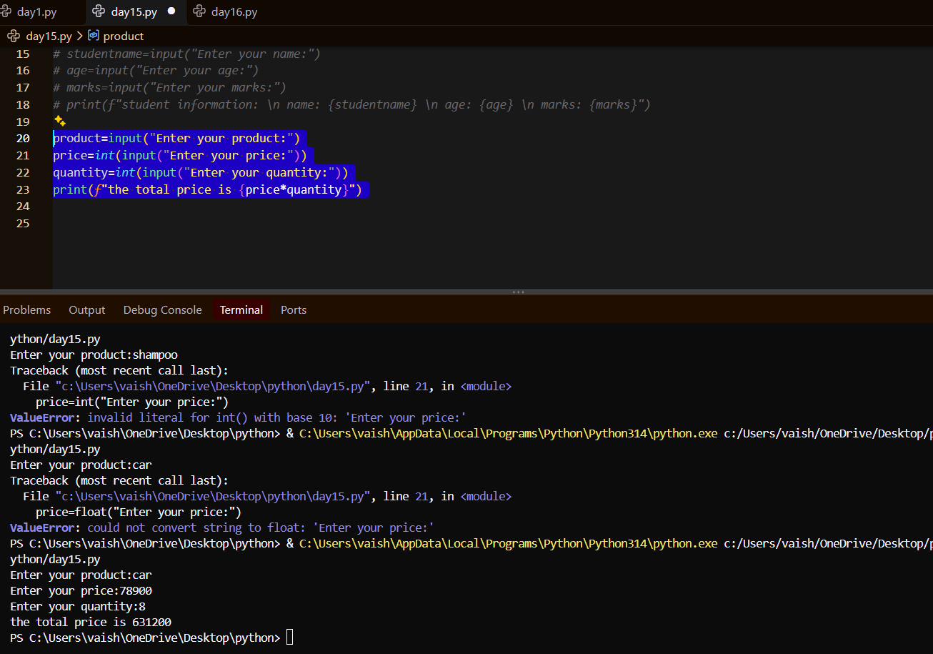

5. Write a program to accept a number and check whether it is positive, negative, or zero.
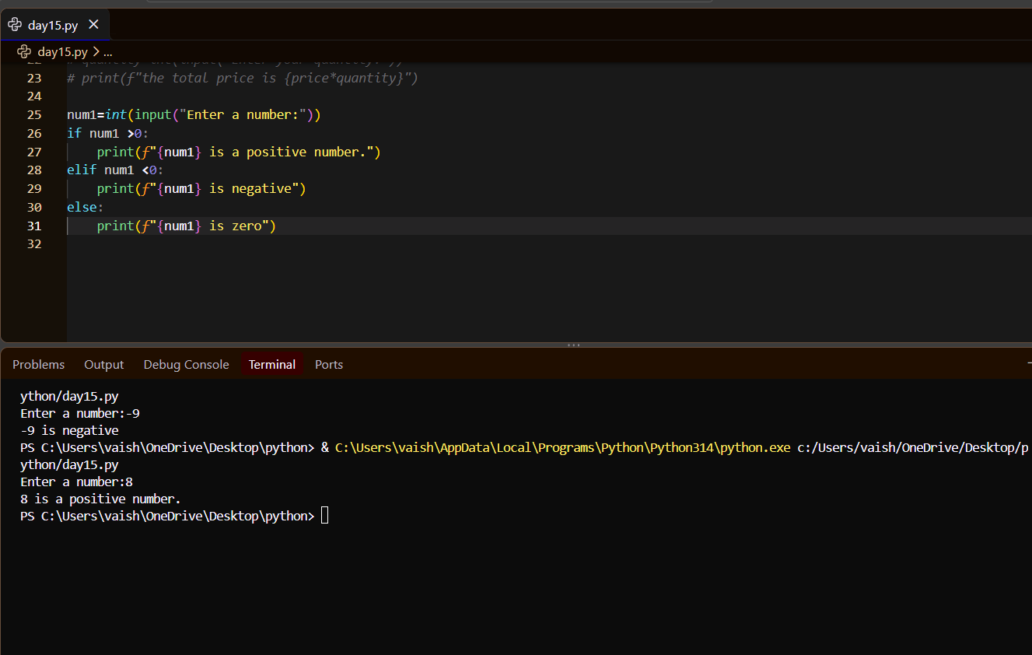
6. Write a program to accept a student's marks and display:
• Pass if marks are 40 or above
• Fail if marks are below 40.
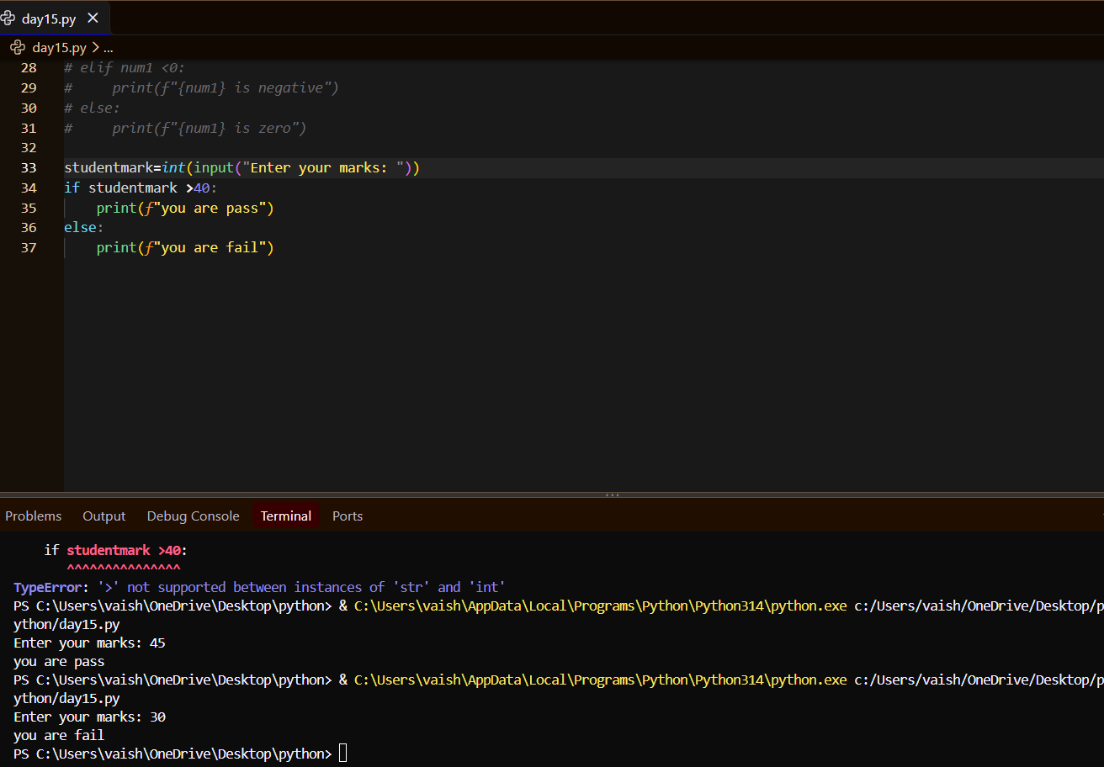
7. Write a program to accept a person's age and determine whether the person is eligible to vote.
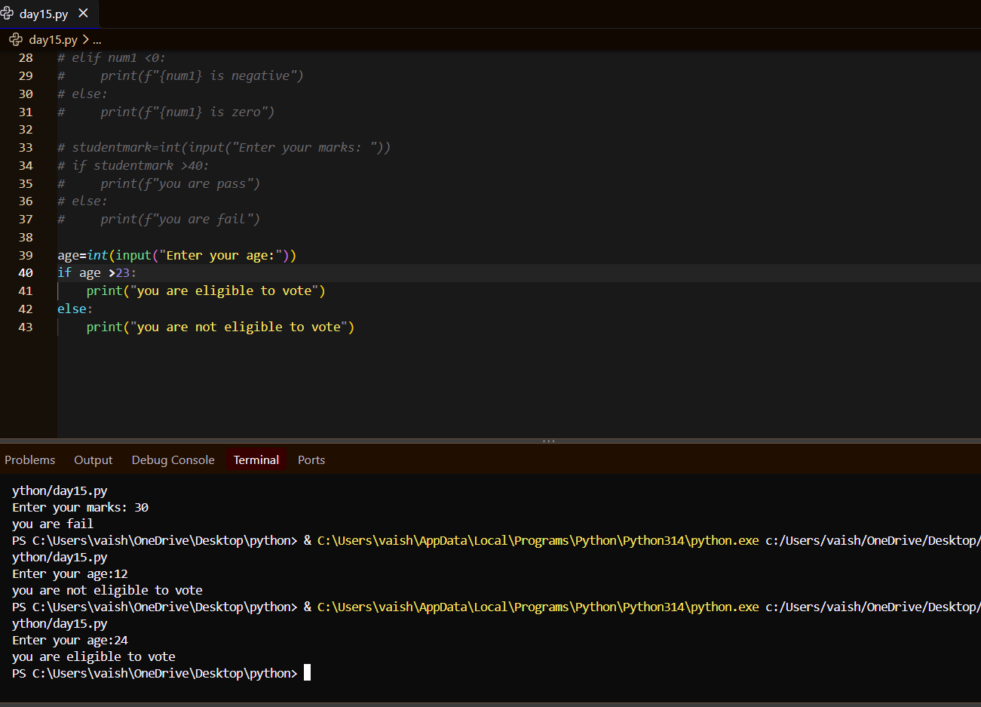
8. Write a program to accept a number and determine whether it is even or odd. If it is even, additionally check whether it is greater than 50.
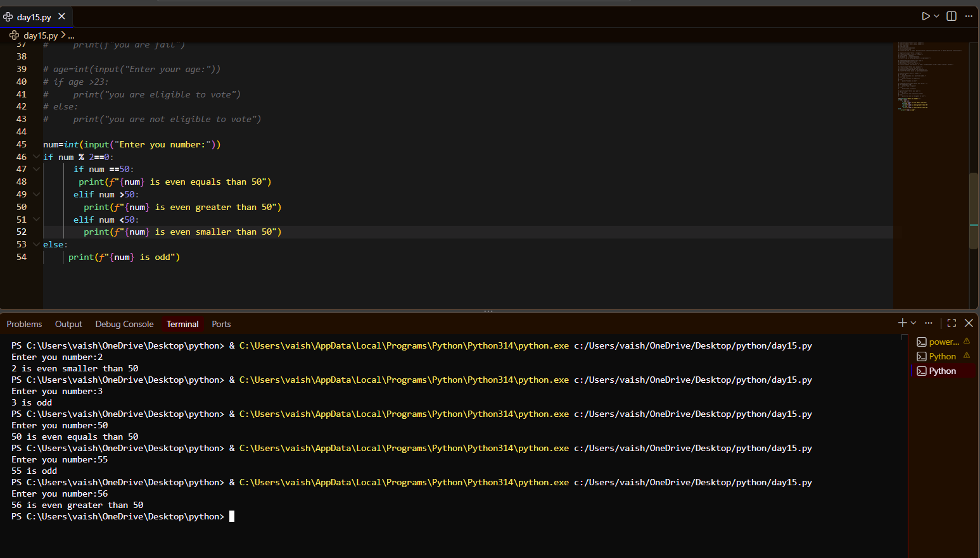

9. Write a program to accept three numbers and find the largest number using nested if statements.
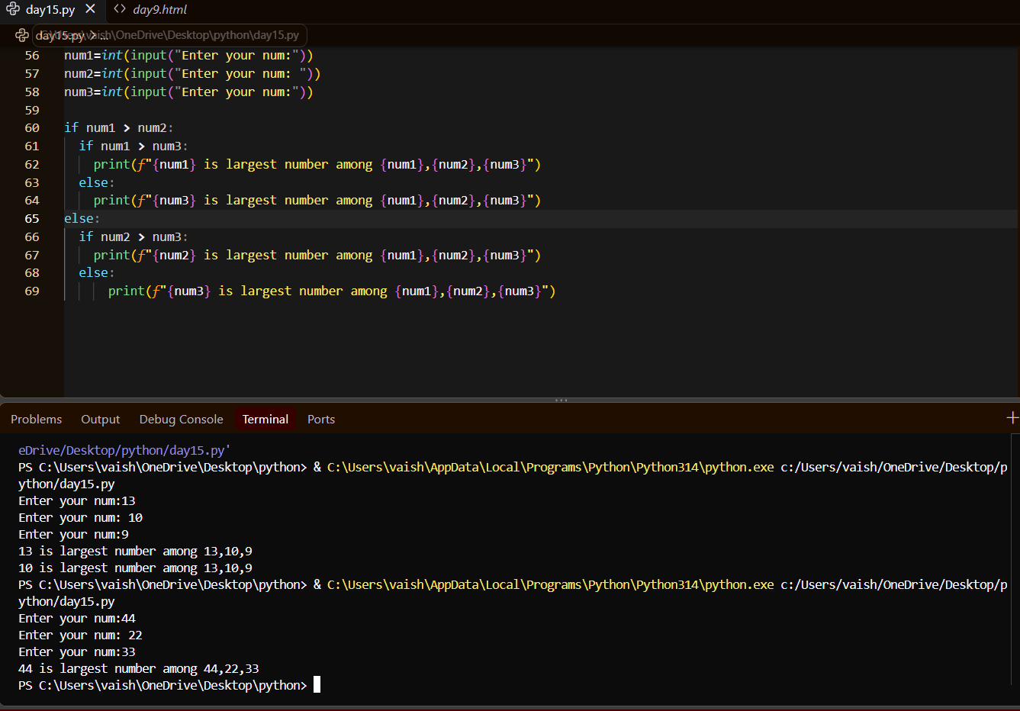
10. Write a program for a simple login system. Ask the user for a username and password. First check whether the username is correct. If it is correct, then check whether the password is correct.
C. for, while & Nested Loops
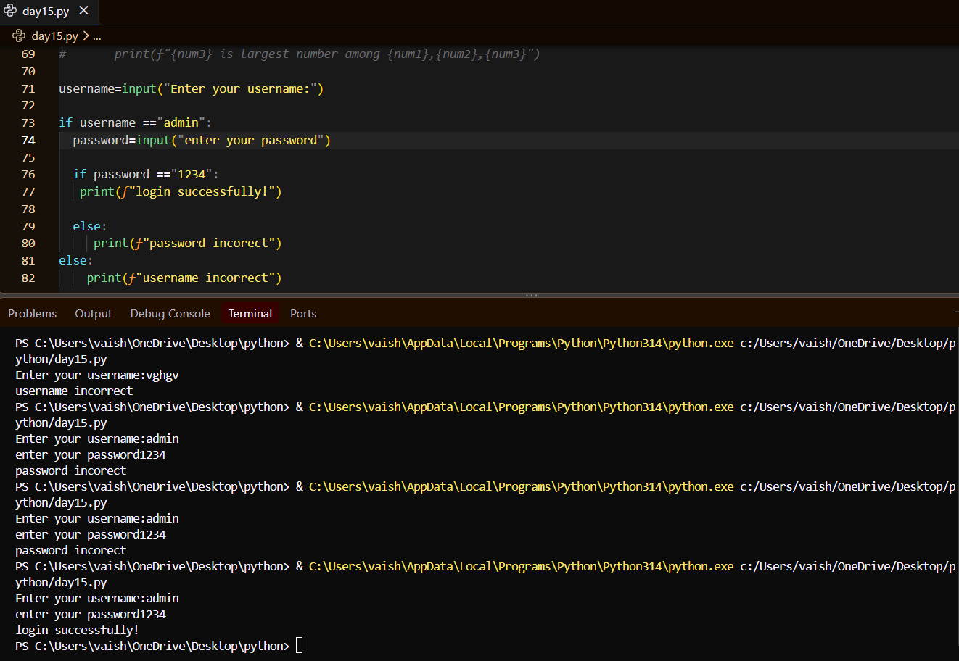
11. Write a program using a for loop to display all numbers from 1 to 20.
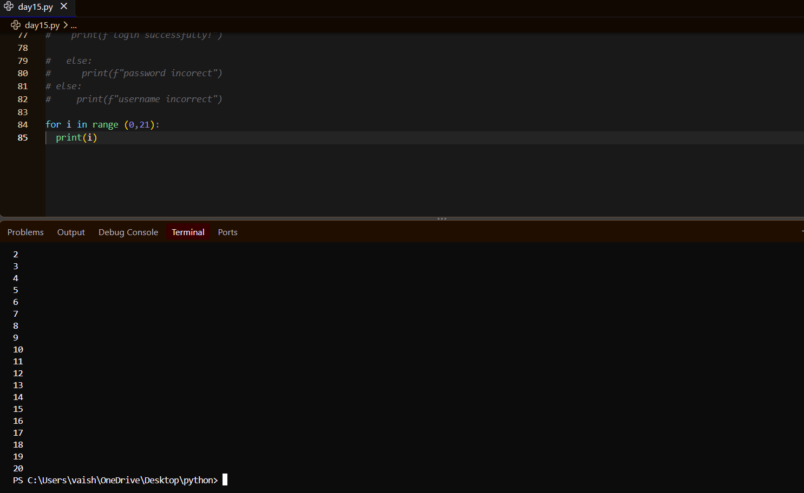
12. Write a program using a while loop to display all even numbers from 2 to 20.
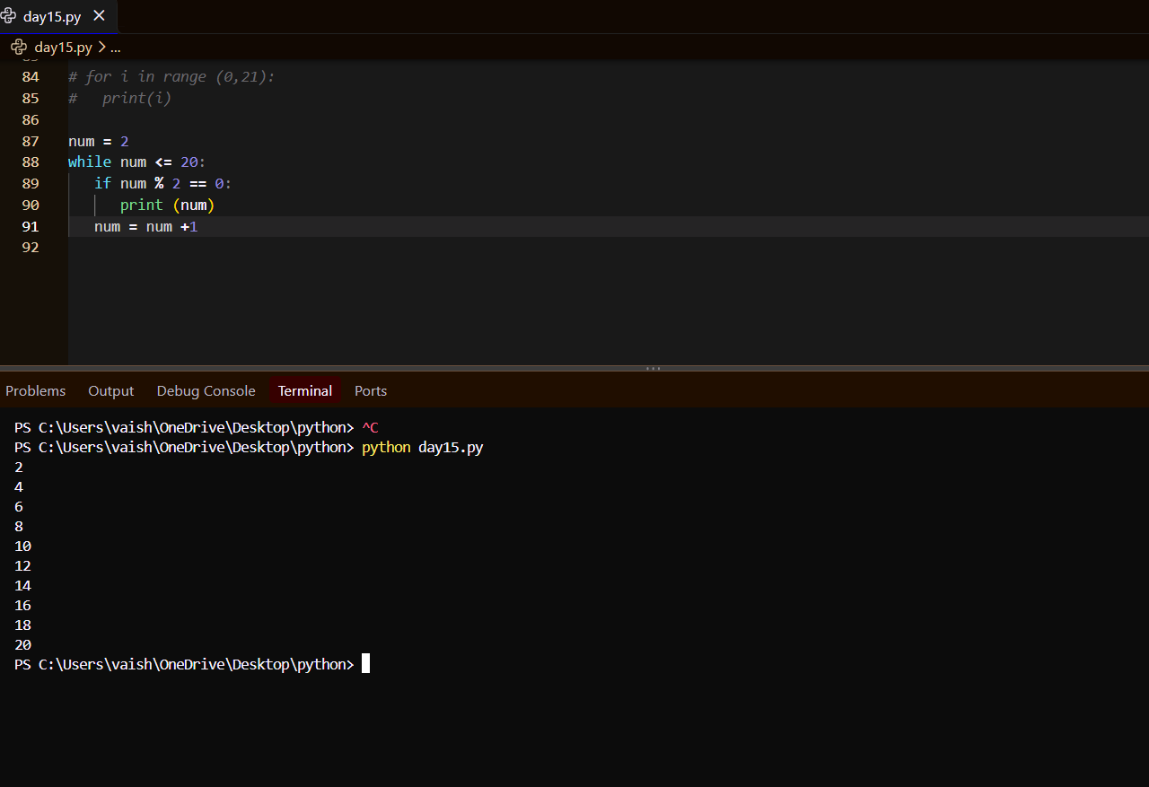
13. Write a program to display the multiplication table of a number entered by the user.
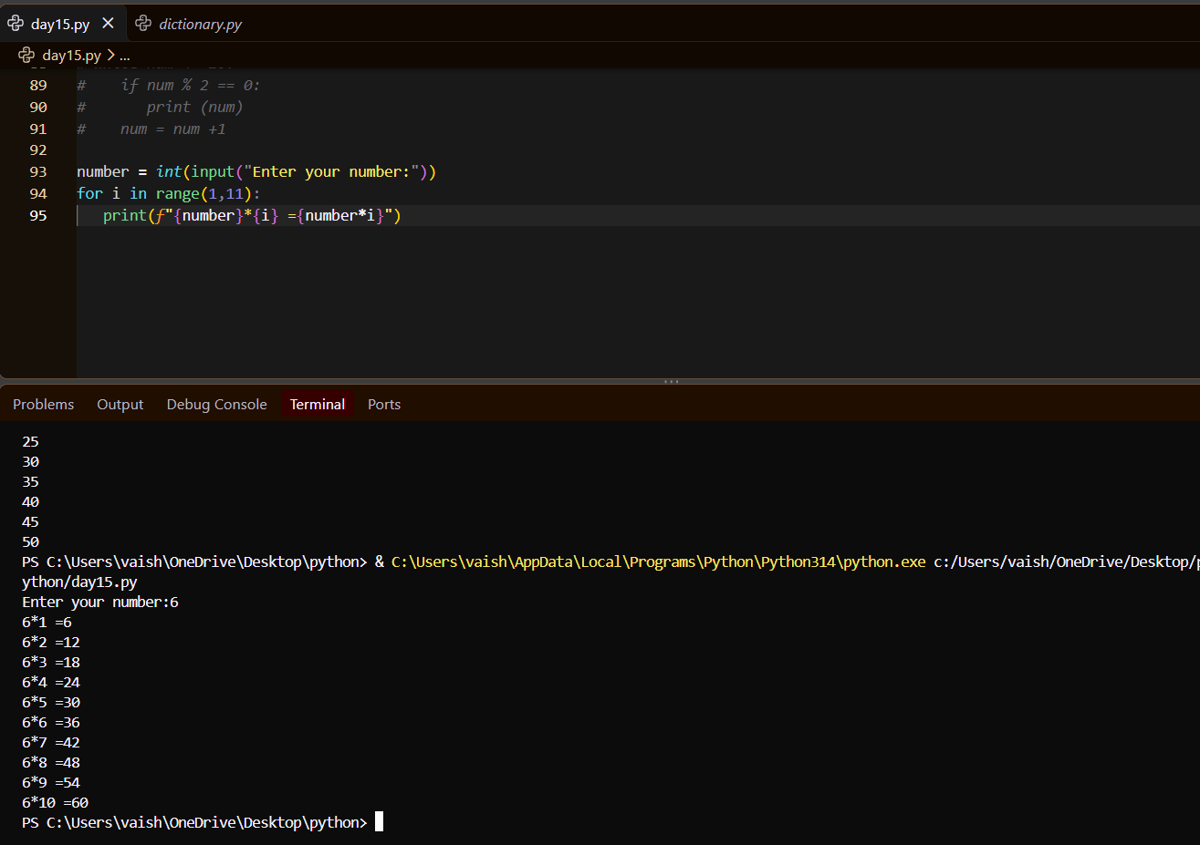
14. Write a program using a for loop to calculate the sum of numbers from 1 to 50.
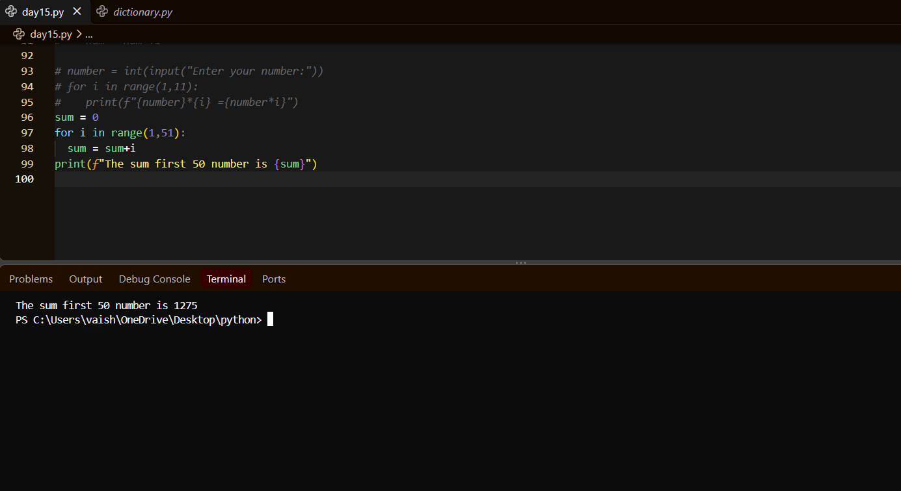

15. Write a program using a nested loop to print the following pattern:
*
**
***
****
*****
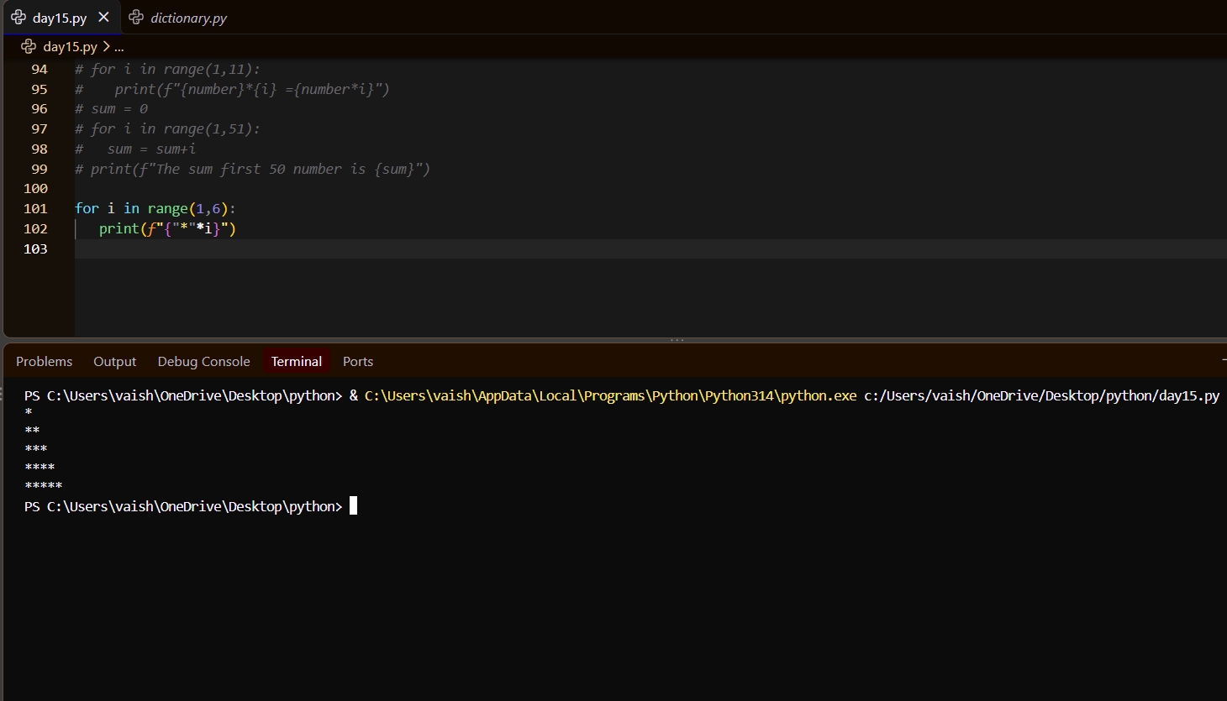
16. Write a program using nested loops to print:
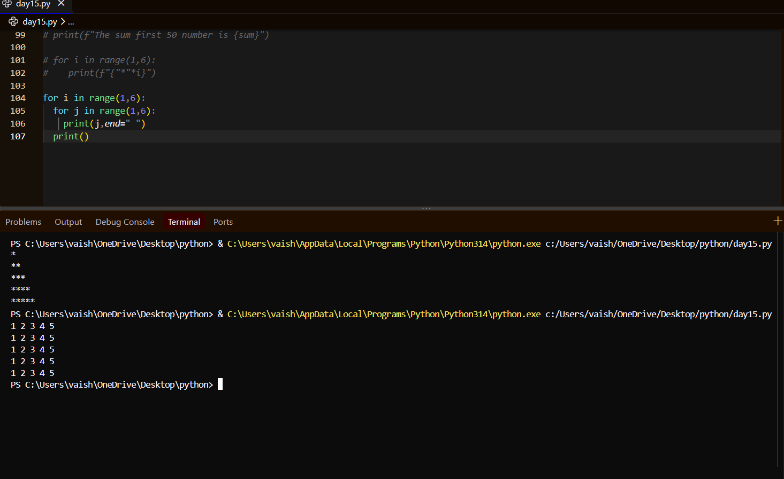

17. Write a Python program to accept a string and use a loop to display each character on a separate line.
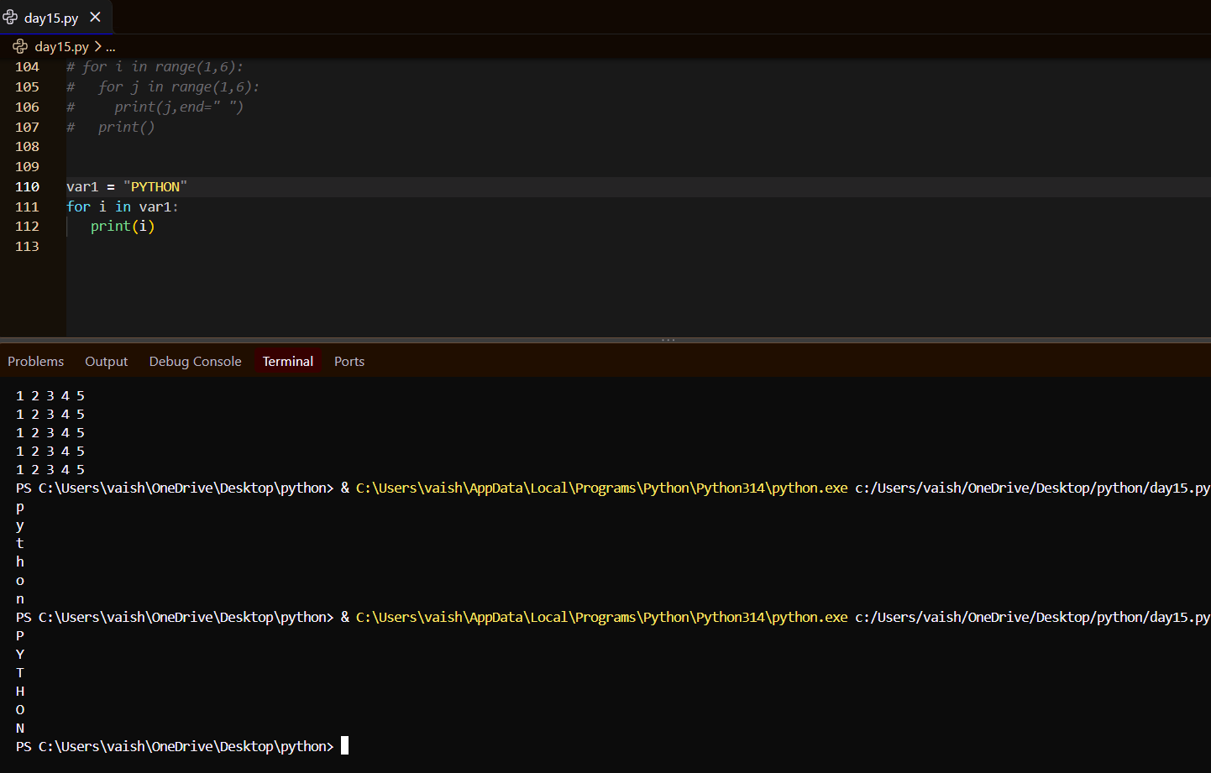
18. Write a program to use a loop to count the number of vowels (a, e, i, o, u) in a string.
E. Lists & Nested Lists
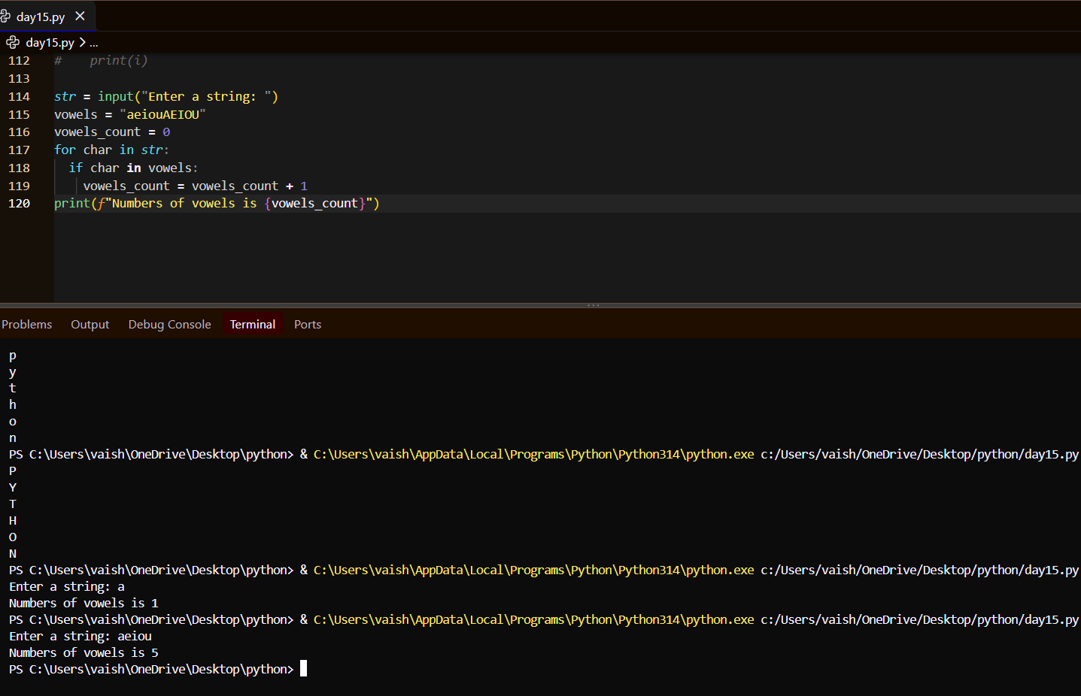
19. Given the following list:
numbers = [10, 25, 8, 45, 32, 15, 50]
Using a loop, display:
• All numbers greater than 20
• The largest number
• The sum of all numbers
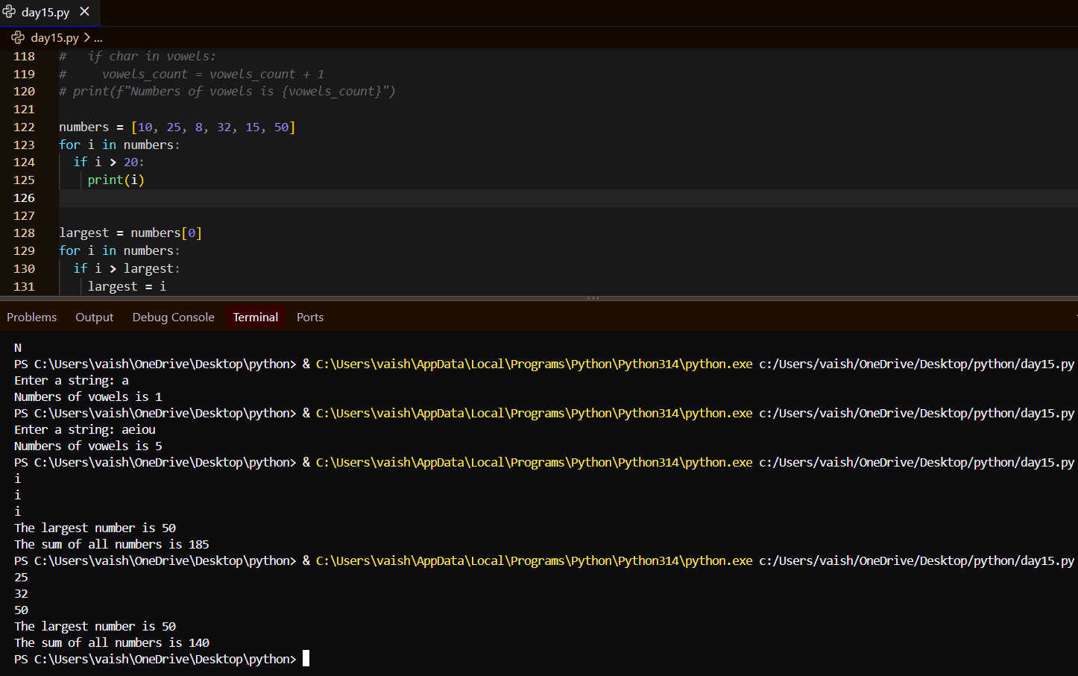
20. Given the nested list:
